Ethan Hitchcock (1408202)

MATH 4315 – Introduction to Graph Theory

Homework #1

1. I was most interested by the paragraph discussing popularity as building on itself to boost interest regarding social media platforms. I had not actively considered that even though a social media network may not offer the best quality experience, its usefulness will grow as more users join the network. I can see aspects of game theory at play with social media platforms as the platform’s popularity will grow as it is recommended by its users and thus the users act as an indirect advertising method.

2) 

The above photo is of the University Lofts apartment building on campus. It is part of a network in which the housing buildings are connected to each other. Each housing building has another network which contains all the residents of each housing building. Within each housing building network may be additional edges due to communities and friendships between residents.

3) Ch 2. #2:

a)

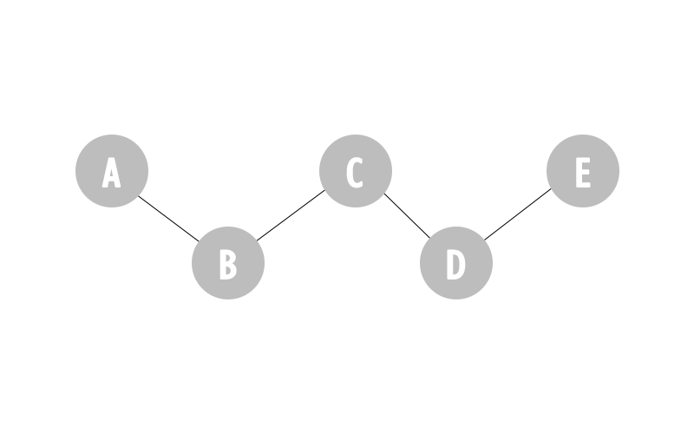

The above is an example of a graph in which more than half of the nodes are gatekeepers. Nodes B, C, and D are all gatekeepers as every path from A to C passes through B, every path from B to D passes through C, and every path from C to E passes through D.

b)

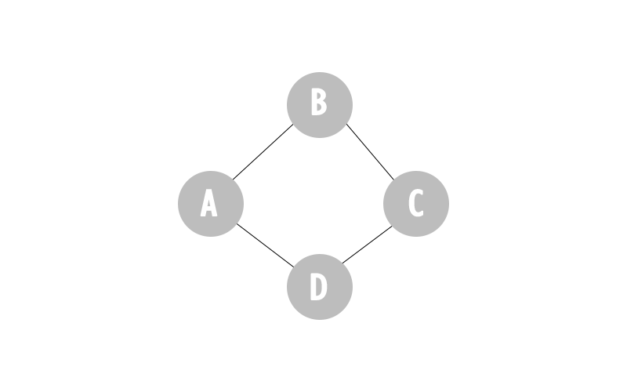

The above is an example of a graph in which there are no gatekeepers, but all nodes are local gatekeepers. This is because for each node pair of nodes, A & C, and B & D, there is an alternate path that can be traversed to get from one member of the pair to the other. For instance, B is a local gatekeeper for A & C because A & C can be connected by the path through node B instead.

4) Ch 2. #3:

a) An example of a graph with an average distance of 1 has connections between all nodes to all other nodes in the network. This means it is possible to get from any node in this network to any other node by traversing a single edge. Following this, if the number of nodes in this network Is larger enough and an additional node is connected to a single node in this network, the average distance will stay approximately equal to 1, while the diameter has increased to 2. If you add another node to this branch, then the diameter would increase to 3 and the average distance would still be approximately 1.

b) Following the above explanation, if there is a sufficiently large number of nodes connected to each other such that the average distance will be approximately 1, it is possible to add (c – 1) nodes to any existing node to increase the diameter to be c. This will result in a diameter which is c times as large as the average distance.

5) a) The vector **k** whose entries are the degrees of the vertices in the network.

b) The number of edges, *m*, in the network

The above can be thought of as half the sum of the degrees of the vertices in the network. The sum of the degrees is halved because as the network is undirected, A­*ij* is the same edge as A*ji*.

c) The matrix N whose entries, *Nij*, equal the number of common neighbours of vertices *i* and *j*.

6) As in Q5, *m* represents the number of edges in a network. As such the mean degree of c1 is and the mean degree of c2 is . It therefore follows that .

7) PT1: Example adjacency matrix represented as a network (Baylor)

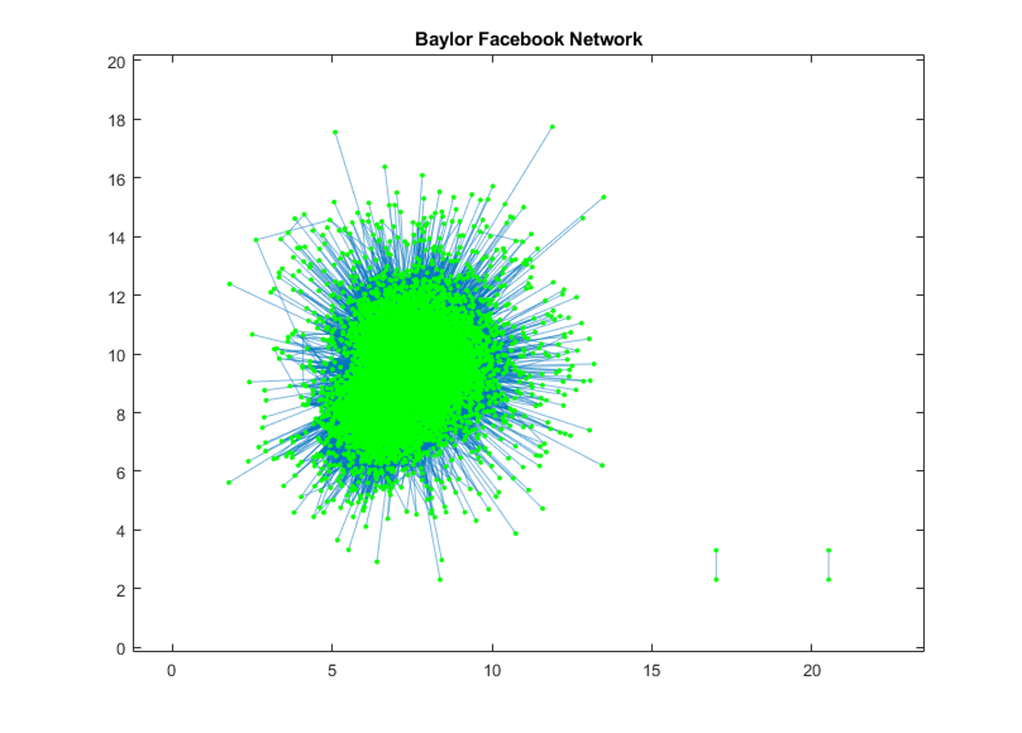

PT2: Attached

PT3:

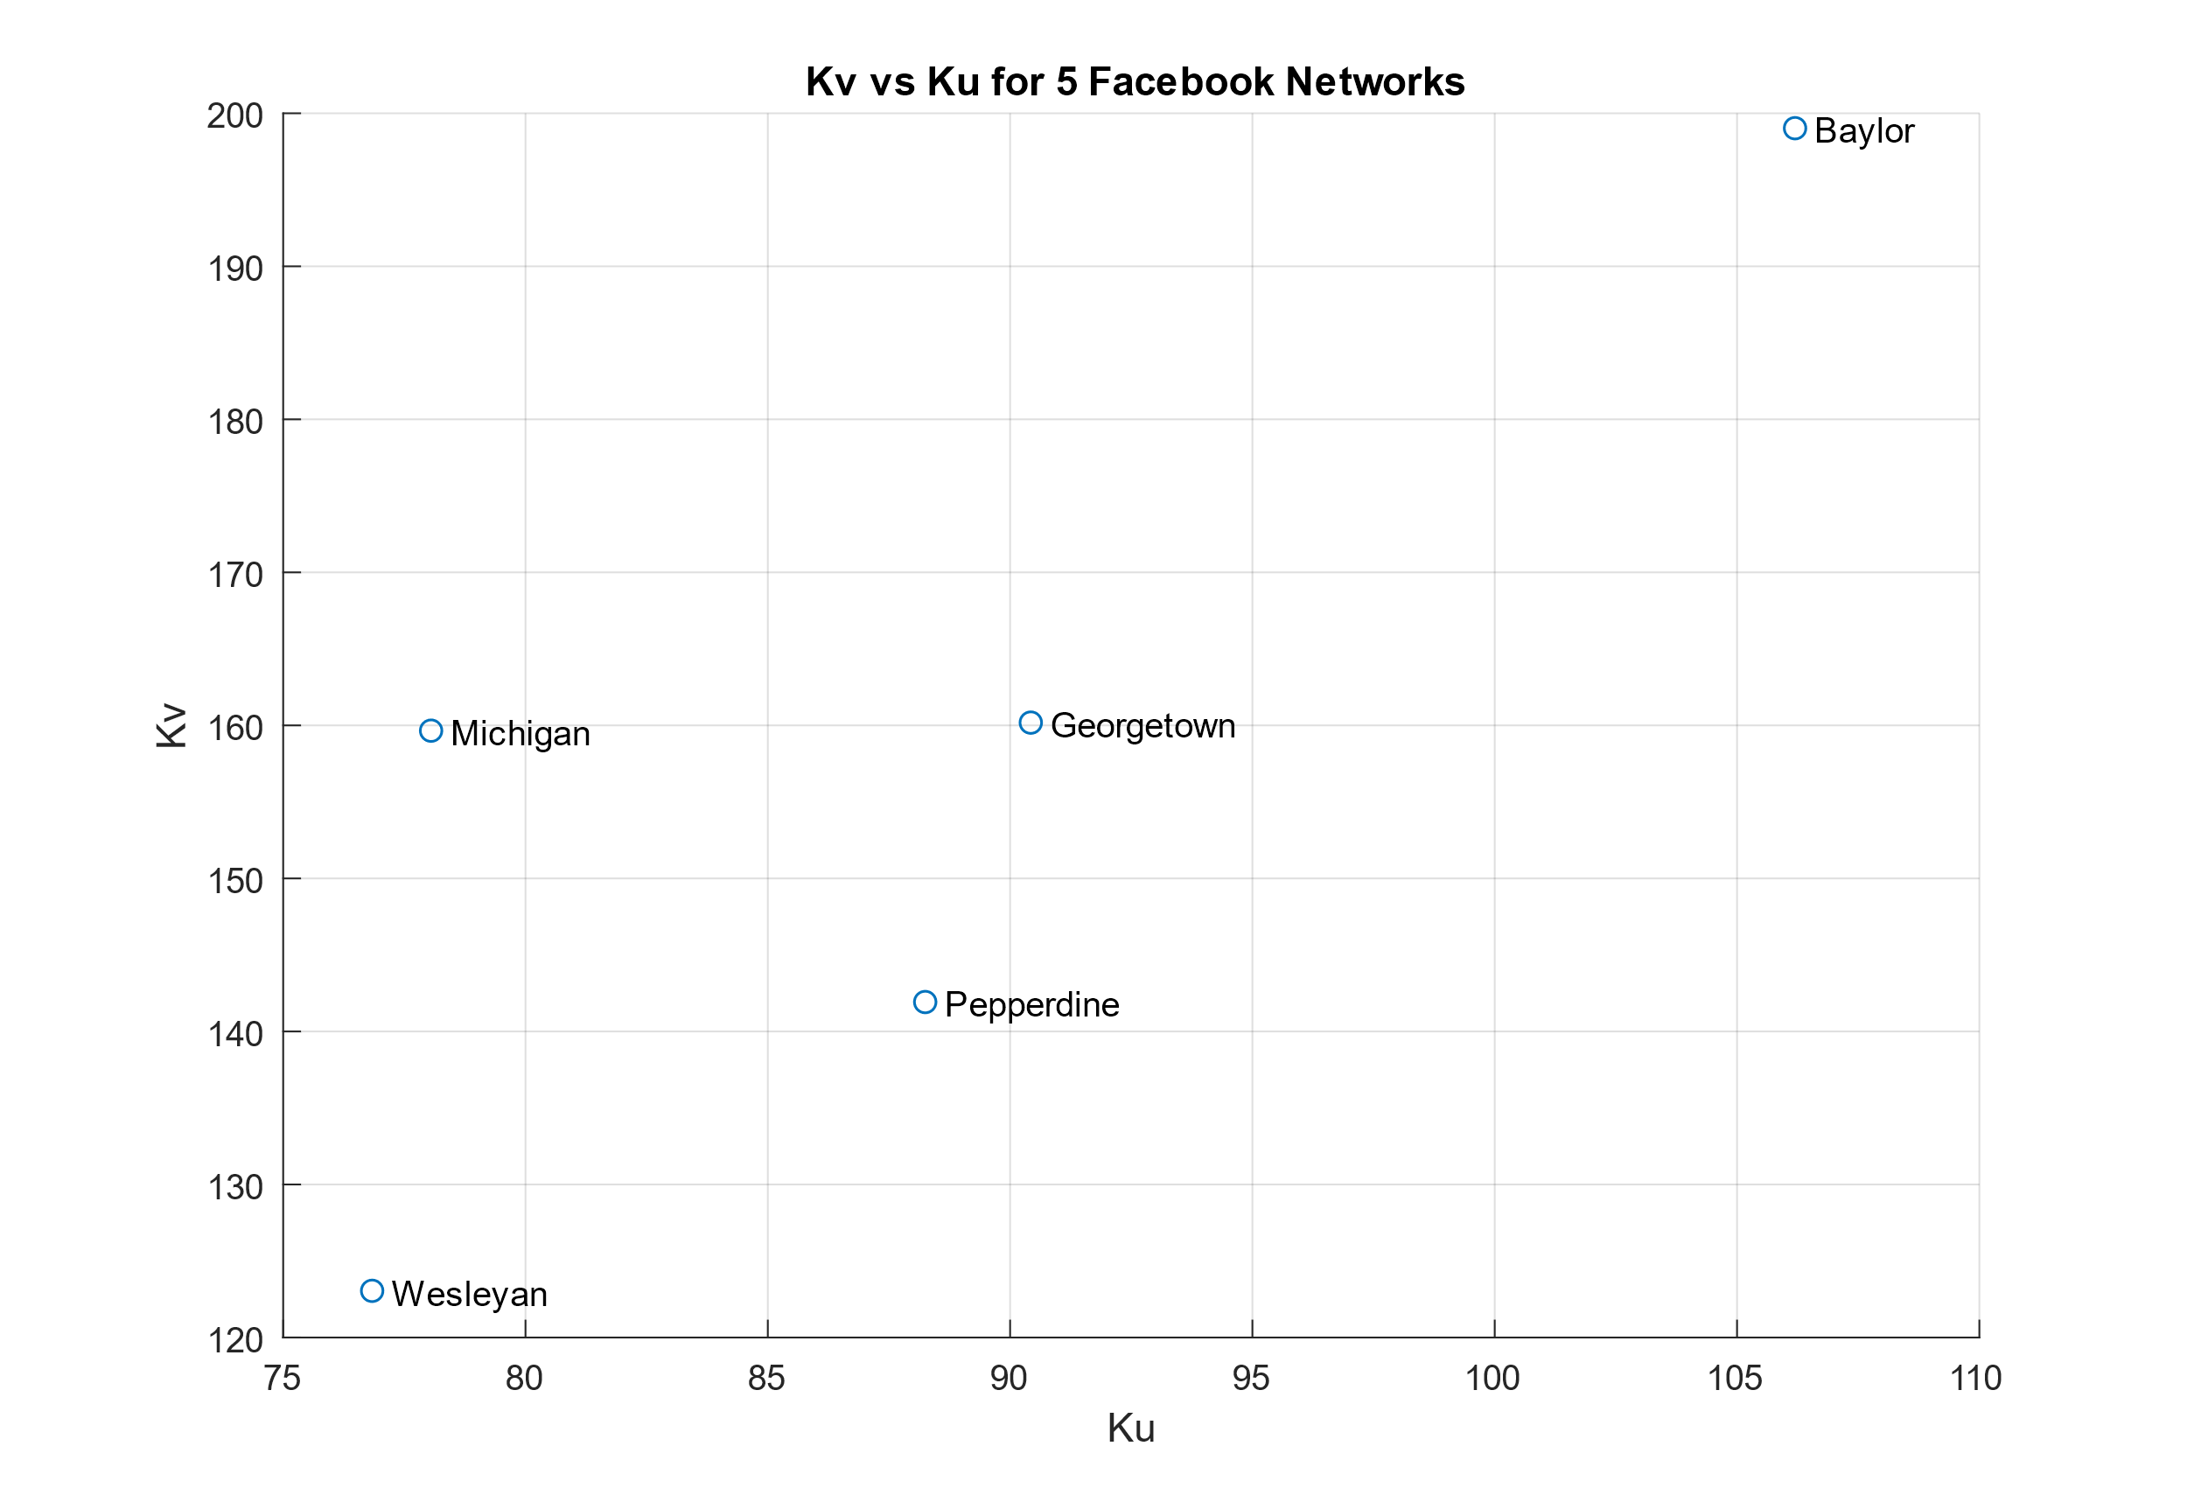

|  |  |  |  |  |  |
| --- | --- | --- | --- | --- | --- |
| School | Baylor | Georgetown | Michigan | Pepperdine | Wesleyan |
| KU | 106.1965 | 90.4266 | 78.05195 | 88.2479 | 76.83551 |
| KV | 199.0257 | 160.1827 | 159.6563 | 141.9239 | 123.0529 |
| KV/Ku | 1.8741 | 1.7714 | 2.0455 | 1.6082 | 1.6015 |

*Table 1: Ku and Kv for Selected Schools*

The friendship paradox can be clearly seen at all the selected schools as each friend has, on average, fewer friends than their friends of friends. Michigan has the largest difference with the average number of friends of friends being 2.05 times larger than the average number of friends for each person. In contrast, Wesleyan had 1.60 times as many average friends of friends as average friends. None of the schools had the same average friends of friends <KV> as average friends <KU>.